Pseudocode for Gulf War Illness Case Definition

**Most recent edit:** 06/15/2021

**Purpose:** Below are the steps used to construct the GWI Illness Case Definition

**Authors:** Beth Gifford and Jackie Vahey

Table of Contents

Glossary 3

Part A. Prepare Symptoms for Analysis 4

Step A1. Select Symptoms for Kansas and CDC definitions 4

Step A2. Infer a symptom is present if responded rated the severity as mild, moderate or severe 5

Step A3. Create new variables that revise the severity score from 0 “No” to 3 “Severe” 5

Part B. Constructing the Kansas GWI definition 6

Step B1. Creating the exclusion criteria 6

Step B1a. Determine the categories for exclusion 6

Step B1b. Create revised diagnosis variables 7

Step B1c. Create Kansas Definition Exclusion Indicator Variable 7

Step B2. For each domain, determine if the respondent did or did not meet multiple or moderate or severe criteria 7

Step B3. Determine if the respondent did or did not meet Kansas symptom criteria 9

Step B4. Determine if the respondent met the criteria for Kansas Gulf War Illness 12

Part C. Constructing the CDC GWI definition 13

Step C1. For each domain, determine if the respondent did or did not meet the domain criteria 13

Step C2. For each domain, determine if the respondent did or did not meet the severe criteria 13

Step C3. Determine if the respondent met the criteria for CDC Gulf War Illness 14

Appendix A. Summary of variables constructed to make the Kansas and CDC definitions 16

Appendix B. Summary of **S**AS programs used to create KS and CDC Caseness 21

Appendix C. Full Pseudocode Flowchart: Revised Variables 22

Appendix D. Full Pseudocode Flow Chart: Kansas Definition 23

Appendix E. Full Pseudocode Flow Chart: CDC Definition 24

Appendix F. Tree Diagram of Phenotypes 25

**List of Figures**

Figure 1. Construction of Revised Symptom and Symptom Rating Variables (Steps A2 and A3) 4

Figure 2. Creating Diagnosis_Rev 6

Figure 3. Kansas Definition of Domains 7

Figure 4. Example Creating the KS Moderate to Severe Domain Criteria 8

Figure 5. Constructing the KS GWI Symptom Criteria 9

Figure 6. Creating the Kansas GWI Caseness Variable 11

Figure 7. Create CDC Domain Criteria and Severe Criteria (steps C1 and C2) 13

Figure 8. Creating CDC GWI Caseness and Severe Caseness 14

# Glossary

* **‘symptom’** refers generically to a specific symptom from the list of Kansas and CDC list. Throughout this document, ‘symptom’ implies that the variable name is the same as in the CSP585 dataset.
* **Rev** short for revised
* **‘diagnosis’** refers generically to a specific diagnosis used in the Kansas definition exclusionary criteria.
* **Domain** refers to a collection of symptoms as defined by the Kansas and CDC studies (see Table 1)
* **‘domain’** refers generically to a specific domain from the list of Kansas and CDC list. For Kansas, the official name of the domains (and abbreviation) are (1) Fatigue & sleep (fatigue), (2) Pain (pain), (3) Neurological/mood/cognition(mood), (4) Gastrointestinal (GI), (5) Respiratory (resp), and (6) Skin (skin). For CDC the official name of the domains (and abbreviation) are (1) Fatigue (Fatigue), (2) Musculoskeletal (pain), (3) Mood-Cognition(mood). Part A. Preparing Variables Related to Symptoms and Severity of Symptoms for the Kansas and CDC Definition.

# Part A. Prepare Symptoms for Analysis

## Step A1. Select Symptoms for Kansas and CDC definitions

Table 1 lists the symptoms from CSP585 used to construct the Kansas and CDC definitions.

|  |  |  |
| --- | --- | --- |
| Table 1. Symptoms Used to Construct the Kansas and CDC Domains | | |
| **Domains** | **KANSAS** | **CDC** |
| **Fatigue & sleep**  **(KS=4 items**  **CDC=2 items)**  Called Fatigue by CDC | 37D Not feeling rested after you sleep |  |
| 37aFatigue | 37aFatigue |
| 37c Problems getting to sleep or staying asleep1 |  |
| 37b Feeling unwell after physical exercise or exertion |  |
| **Pain (3 items for KS & CDC)**  Called Musculoskeletal by CDC | 37e pain in your joints | 37e pain in your joints |
|  | 37f stiffness in your joints |
| 37g. Pain in your muscles | 37g. Pain in your muscles |
| 37h. Body pain where you hurt all over |  |
| **Neurological/ mood /cognition**  **(KS=14 items**  **CDC=7 items)**  Called Mood-Cognition by CDC | 37cc. Difficulty remembering recent information | 37cc. Difficulty remembering recent information |
| 37ff. Feeling irritable or having angry outbursts |  |
| 37m. numbness or tingling in your extremities |  |
| 37i. headaches |  |
| 37k. eyes very sensitive to light |  |
| 37dd. Trouble finding words when speaking | 37dd. Trouble finding words when speaking |
| 37ee. Feeling down or depressed | 37ee. Feeling down or depressed |
| 37bb. Difficulty concentrating | 37bb. Difficulty concentrating |
| 37p. night sweats |  |
| 37j Feeling dizzy, lightheaded or faint |  |
| 37o. low tolerance for heat or cold |  |
| 37q. having physical or mental symptoms in response to certain smells or chemicals |  |
| 37l. blurred or double vision |  |
| 37n. tremors or shaking |  |
|  | 37c. Problems getting to sleep or staying asleep |
|  | 37gg. Feeling moody |
|  | 37hh. Feeling anxious |
| **GI (3 items-KS-only)** | 37t. Diarrhea |  |
| 37u. Nausea or upset stomach |  |
| 37v. Abdominal pain or cramping |  |
| **Respiratory (3 items-KS-only)** | 37w. Difficulty breathing or shortness of breath |  |
| 37x. Frequent coughing when you don’t have a cold |  |
| 37y. wheezing in your chest |  |
| **Skin (2 items-KS-only)** | 37r. rashes |  |
| 37s. other skin |  |
| 1 Note that this symptom is used in the CDC definition but under mood domain rather than the fatigue domain | | |

## Step A2. Infer a symptom is present if respondent rated the severity as mild, moderate or severe

For the symptoms used in (a) Kansas and (b) CDC definition (see Table A1), we create new variables **[‘symptom’_Rev**] that revise **‘symptom’** responses to account for survey missing response patterns and the MVP standard of updating less specific information when it is in conflict with a more specific answer. If the respondent rated the severity of the symptom as “mild”, “moderate”, or “severe” (e.g., **‘symptom’Rate)** then “missing” & “no” responses to the **‘symptom’** become “yes” to indicate that the person experienced the symptom.

These new **‘symptom’_Rev** variables are used for all calculations in the Kansas and CDC definitions.

## Step A3. Create new variables that revise the severity score from 0 “No” to 3 “Severe”

For the purposes of programming, we create new variables that revise the severity score. Specifically, if the respondent indicated “no” to having a symptom, then we treat the severity rating as “no” and assign the value 0. The new variables are named **‘symptom’Rate_Rev** (figure 1).

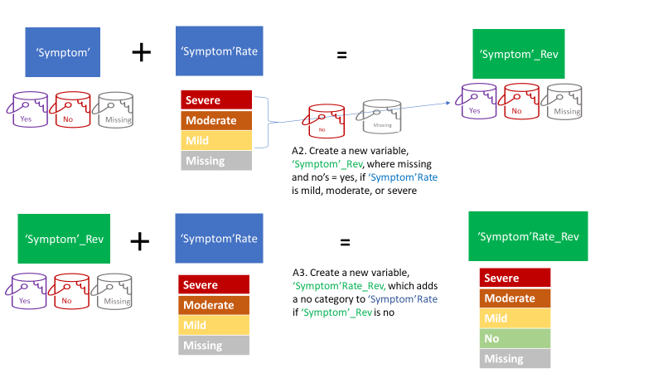

Figure 1. Construction of Revised Symptom and Symptom Rating Variables (Steps A2 and A3)

# Part B. Constructing the Kansas GWI definition

## Step B1. Creating the exclusion criteria

The Kansas GWI definition excludes individuals from being eligible for having GWI if they have been previously diagnosed with certain conditions. Table 2 lists the exclusion criteria that were used for the CSP 585 sample.

### Step B1a. Determine the categories for exclusion

|  |  |
| --- | --- |
| Table 2. List of Exclusionary Criteria Used for the Kansas Definition | |
| **Exclusion Criteria** | Question #/ Variable name |
| **All Cancers** |  |
| Brain | CaBrain |
| Breast | CaBrst |
| Colon | CaColon |
| Lung | CaLung |
| Prostate | CaPros |
| Melanoma (where available) | Not available in CSP585. |
| Other | CaOth |
| **Diabetes** | DoDM |
| **Heart Disease** |  |
| Heart Attack | CircHrtAtk |
| Coronary artery disease | CircCAD |
| Congestive heart failure | CircCHF |
| **Stroke** | CircStrk |
| Transient ischemic attack | CircTIA |
| **Infectious Disease** |  |
| HIV | IDHIV |
| Tuberculosis | IDTB |
| Hepatitis C | IDHepC |
| Liver disease | DoLiver |
| Lupus | DoLupus |
| Schizophrenia | MHSCZ |
| Bipolar | MHBPD |
| Multiple Sclerosis | NSMS |
| TBI | NSTBI |

### Step B1b. Create revised diagnosis variables

Create a variable called **‘diagnosis’_Rev** for each diagnosis that is ‘yes’ if the person reported having **‘diagnosis’** (figure 2). In addition, if the respondent reported a **‘yeartold’** but whose **‘diagnosis’** is no or missing, then the **‘diagnosis’_Rev** marked yes.

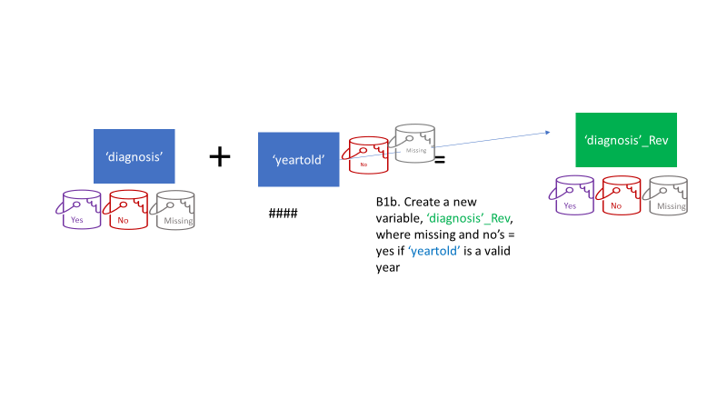

Figure 2. Creating Diagnosis_Rev

### Step B1c. Create Kansas Definition Exclusion Indicator Variable

Create a variable called **KS_Excl** as follows:

* **Yes** if the respondent answered “yes” to any of the revised exclusion criteria **‘diagnosis’_Rev** (Table 2).
* **No** if the respondent answered “no” to all of the revised exclusion criteria **‘diagnosis’_Rev** (Table 2).
* **Missing**If the respondent has not responded “yes” to any of the **‘diagnosis’_Rev** but has at least 1 missing item in the exclusionary criteria.

We also create a variable called **KS_Excl_NumMiss** which is a count of missing items among the revised exclusion criteria **‘diagnosis’_Rev** (table 2).

## Step B2. For each domain, determine if the respondent did or did not meet multiple or moderate or severe criteria

This section describes how to construct the 6 variables which document whether or not the veteran met the moderate or multiple criteria of the Kansas Domains (figure 3). Figure 4 demonstrates how to construct the moderate-multiple criteria for the fatigue domain.

***For each symptom domain:***

Once a person meets the “yes” criteria then they are a yes and they remain in that category. The following criteria qualify a person for “yes”:

1. **Multiple Symptoms:** if the respondent answered “yes” to more than 1 ‘**symptom’_Rev** in the domain **and/or**
2. **Moderate-to-Severe:** at least 1 **‘symptom’Rate_Rev** was coded as “moderate” or “severe”.   
   *Note, in the CSP585 repository, if the veteran marked multiple severity scores (among mild, moderate, several) these were recorded in the data as “81-multiple responses”; In our sas dataset we have used* ***.b*** *as the extended SAS missing code for 81. These should be treated as moderate or severe for this calculation, as it is impossible for a multiple answer options toinclude neither moderate or severe.*

To distinguish between “No” and “Missing”:

* **No**: all three of the below bullets must be true:
  + Zero or one **‘symptom’_Rev** marked “yes”
  + Zero revised **‘symptom’Rate_Rev** were marked as “moderate” or “severe”
  + There were zero items missing in **‘symptom’Rate_Rev**
* **Missing:** 1 or more **‘symptom’Rate_Rev** items had missing values. *This is because a single “yes, moderate” or “yes, severe” is enough to change a domain from “no” to “yes”.*

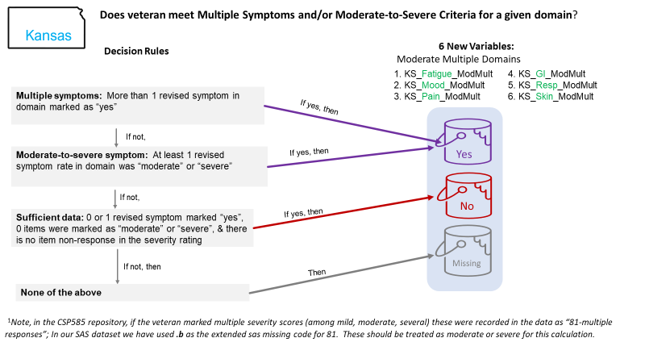

Figure 3. Kansas Definition of Domains

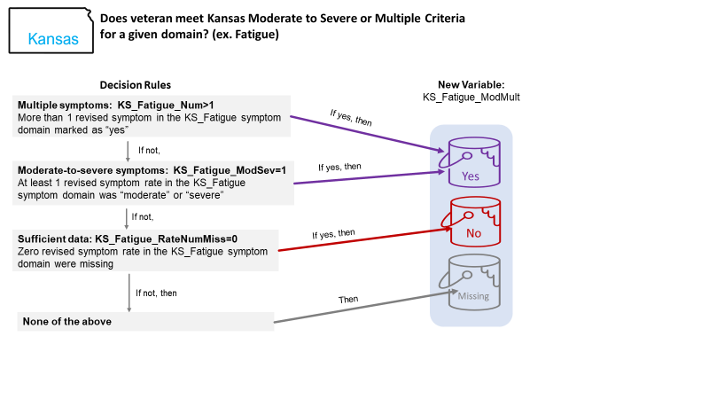

Figure 4. Example Creating the KS Moderate to Severe Domain Criteria

## 

## Step B3. Determine if the respondent did or did not meet Kansas symptom criteria

To denote whether or not the veteran met the *symptom criteria* for the Kansas GWI definition, we constructed a variable called KS_GWI_ModMult_SC (see figure 5). Table 3 lists all of the possible combinations of the 6 Kansas domains to determine whether or not the veteran met the symptom criteria.

In summary, this variable is:

* **Yes:** If 3 or more multiple/moderate-to-severe symptom domains are “yes”, then respondent met Kansas Definition Symptom Criteria
* **No:** If 4 or more multiple/moderate-to-severe symptom domains are ”no”, the respondent does not meet Kansas Definition Symptom Criteria.
* **Missing:** If neither 3 or more multiple/moderate-to-severe symptom domains are “yes” or 4 or more multiple/moderate-to-severe symptom domains are “no”, then the Kansas Definition Symptom Criteria is missing. “Missing” Kansas Definition Symptom Criteria indicates that the true (but unknown) value of the information that is missing from the survey questionnaire could change the value of the Kansas Definition Symptom Criteria indicator.

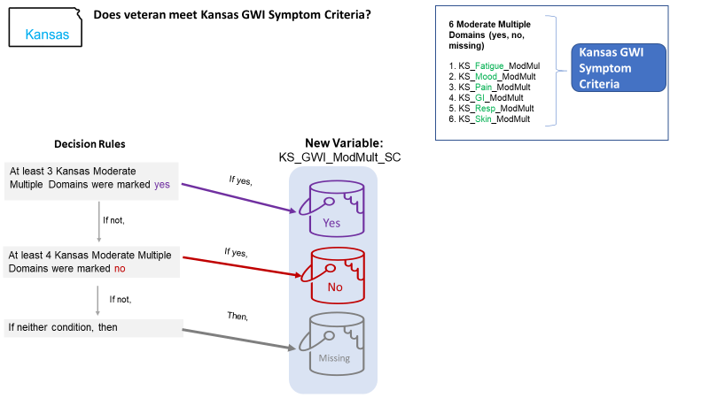

Figure 5. Constructing the KS GWI Symptom Criteria

|  |  |  |  |
| --- | --- | --- | --- |
| Table 3. Does the Veteran Meets the Kansas GWI Symptom Criteria?: All Combinations of the 6 Kansas Domains to Determine Whether or Not | | | |
| Number of Kansas Domains Marked Yes | Number of Kansas Domains Marked No | Number of Kansas Domains Marked Missing | Does Veteran Meet Kansas Symptom Criteria? |
| 6 | 0 | 0 | Yes |
| 5 | 0 | 1 | Yes |
| 5 | 1 | 0 | Yes |
| 4 | 0 | 2 | Yes |
| 4 | 1 | 1 | Yes |
| 4 | 2 | 0 | Yes |
| 3 | 0 | 3 | Yes |
| 3 | 1 | 2 | Yes |
| 3 | 2 | 1 | Yes |
| 3 | 3 | 0 | Yes |
| 2 | 0 | 4 | Missing |
| 2 | 1 | 3 | Missing |
| 2 | 2 | 2 | Missing |
| 2 | 3 | 1 | Missing |
| 2 | 4 | 0 | No |
| 1 | 0 | 5 | Missing |
| 1 | 1 | 4 | Missing |
| 1 | 2 | 3 | Missing |
| 1 | 3 | 2 | Missing |
| 1 | 4 | 1 | No |
| 1 | 5 | 0 | No |
| 0 | 0 | 6 | Missing |
| 0 | 1 | 5 | Missing |
| 0 | 2 | 4 | Missing |
| 0 | 3 | 3 | Missing |
| 0 | 4 | 2 | No |
| 0 | 5 | 1 | No |
| 0 | 6 | 0 | No |

## Step B4. Determine if the respondent met the criteria for Kansas Gulf War Illness

This section combines information from the Kansas symptom criteria with the exclusionary criteria to determine whether or not the veteran met the Kansas GWI definition (see figure 6). Table 4 provides all of the possible combinations of Kansas GWI symptom criteria and the exclusion criteria and how these combinations are reflected in the Kansas GWI case status.

* **Yes:** Respondents who met Kansas Definition Symptom Criteria **and** who did not meet the Exclusionary Criteria **and** had no missing Exclusionary Criteria.
* **No:**
  + Respondents who did not meet Kansas Definition Symptom Criteria, **or**
  + Respondent who met exclusionary criteria
* **Missing:** Respondents who were classified as missing Kansas Definition Symptom Criteria **or** who were missing exclusionary criteria.

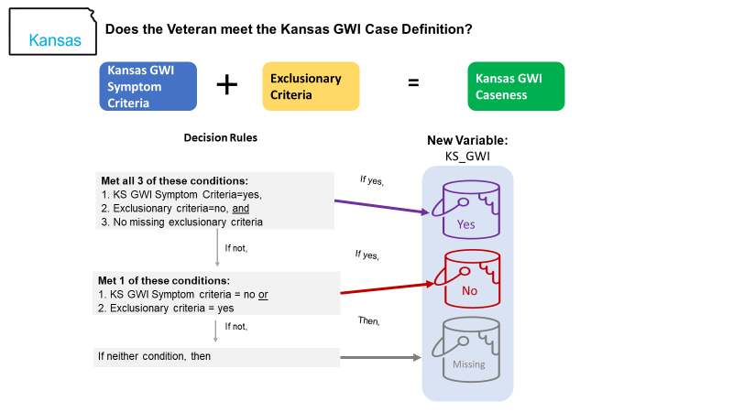

Figure 6. Creating the Kansas GWI Caseness Variable

|  |  |  |
| --- | --- | --- |
| Table 4. Does Veteran meet KS GWI case definition? | | |
| Veteran meets Kansas symptom criteria | Veteran endorsed yes on at least one exclusionary condition | Kansas Definition Case Status |
| Yes | No | Yes |
| Yes | Yes | No |
| No | Yes | No |
| No | No | No |
| Yes | Missing | Missing |
| No | Missing | Missing |
| Missing | Missing | Missing |
| Missing | Yes | Missing |
| Missing | No | Missing |

# Part C. Constructing the CDC GWI definition

The CDC GWI definition is composed of 3 domains: fatigue; mood and cognition; and musculoskeletal (see table 1 for symptoms that compose each domain). Figure 7 depicts the logic for combining possible combinations of the symptoms to determine whether or not the veteran (a) meets the domain criteria and (b) meets the “severe” domain criteria.

## Step C1. For each domain, determine if the respondent did or did not meet the domain criteria

Construct 3 variables 1 for each domain named **CDC_‘domain’_Any** which are scored as follows:

* “Yes” if the respondent answered yes to any **‘symptom’_Rev** within the domain
* “No” if respondent answered no to each **‘symptom’_Rev** within the domain
* “Missing” if respondent did not answer yes to any **‘symptom’_Rev** within the domain and at least one **‘symptom’_Rev** is missing

## Step C2. For each domain, determine if the respondent did or did not meet the severe criteria

Construct three variables (one for each domain) named **CDC_‘domain’_sev** which are scored as follows:

* “Yes” if the respondent answered “severe” to any of the **‘symptom’Rate_Rev** within the domain
* “No” if none of the **‘symptom’Rate_Rev** within the domain are “severe” *and* none of the **‘symptom’Rate_Rev** within the domain are missing
* “Missing” if none of the **‘symptom’Rate_Rev** are “severe” *and* none of the **‘symptom’Rate_Rev** within the domain are missing

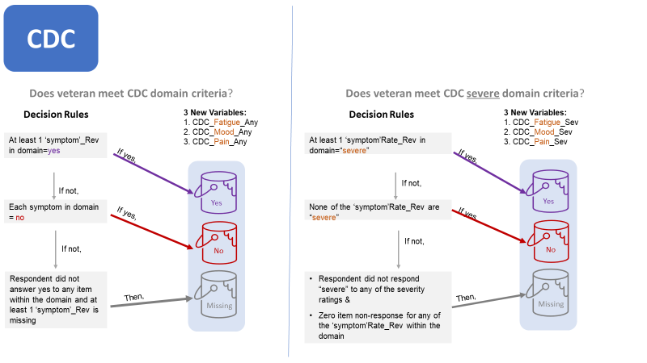

Figure 7. Create CDC Domain Criteria and Severe Criteria (steps C1 and C2)

## 

## Step C3. Determine if the respondent met the criteria for CDC Gulf War Illness

Construct two variables (1) CDC_GWI and (2) CDC_GWI_Sev to identify if respondent meet the CDC GWI case definitions (see table 5 and figure 8).

**CDC Gulf War Illness Case Status**

* “Yes” if the respondent met two or three domain criteria
* “No” if the respondent met zero or one domain criteria
* “Missing” if the respondent did not meet the yes criteria and had fewer than two no’s

|  |  |  |  |  |
| --- | --- | --- | --- | --- |
| Table 5. Does the Veteran Meet the CDC GWI Caseness Definition? | | | | |
|  | # of domains with no | | | |
| # of domains marked yes | 0 | 1 | 2 | 3 |
| 0 | Insufficient Information  to Determine Caseness | | No | No |
| 1 | No |  |
| 2 | YES | YES |  |  |
| 3 | YES |  |  |  |
| Black = Combination not possible because there are only 6 domains  Yes = Meets CDC GWI Symptom Criteria  No = Does not Meet GWI Symptom Criteria | | | | |

**CDC Gulf War Illness Severity Case Status**

* “Yes” if at least one CDC symptom in at least two domains were ranked as severe.
* “No” if, in at least two domains, all symptoms were marked as no, mild, or moderate.
* “Missing” if neither of the above statements is true.

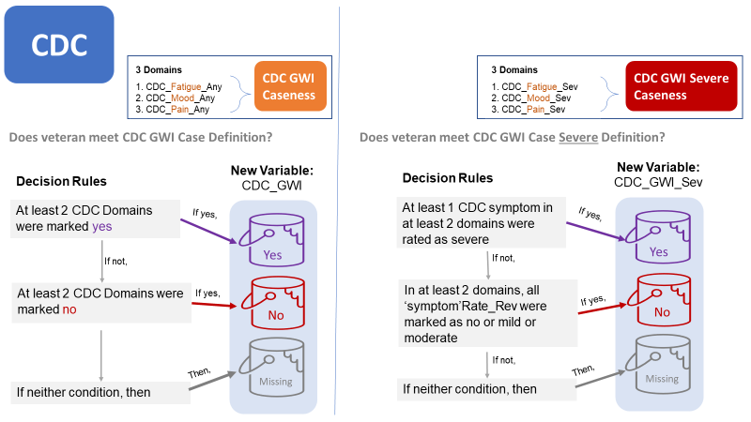

Figure 8. Creating CDC GWI Case Status and CDC GWI Severe Case Status

# Appendix A. Summary of variables constructed to make the Kansas and CDC definitions

|  |  |  |  |  |
| --- | --- | --- | --- | --- |
| Variable name | Variable Label | Value Label | Calculation | Notes |
| **For each symptom** | | | | |
| ‘symptom’_Rev | “`symptom label’ Revised to account for severity information” | 1=Yes  0=No  .=missing | **Generates a new variable that replaces missing values with yes if a severity for that symptom was given** | ‘symptom’ refers to the original variable name |
| ‘symptom’Rate_Rev | “`symptom’Rate label’ Revised to account for valid skips” | 0=No  1=Mild  2=Moderate  3=Severe | **Generates a new variable that codes missings as severity scores as 0 rather than missing –reflecting the valid skip pattern** | This is helpful for programming the definitions; Drew has suggested more consideration of this for an analytic variable |
| **For each diagnosis** | | | | |
| ‘diagnosis’_Rev | “`diagnosis label’ Revised to account for severity information” | 1=Yes  0=No  .=missing | **Generates a new variable that replaces missing values with yes if a year told for that diagnosis was valid** | ‘diagnosis’ refers to the original variable name |
| **For the Kansas Definition** | | | | |
| KS_Excl | “Meets Kansas Exclusion Criteria” | 1=Yes  0=No  .=missing | **Yes= If at least 1 of the exclusionary criteria is yes, then the veteran was considered to have met the exclusion criteria;**  **.=if the veteran is not yes but has a missing item among the exclusionary criteria then missing exclusion criteria**  **0= if all of the exclusionary criteria are no** | **exclusionary criteria are listed in Table 2** |
| KS_Excl_NumMiss | “Number of missing exclusion criteria” | Integer: 0-(number of exclusionary conditions) | **Number of missing items among the exclusionary criteria are listed in Table 2** |  |
| KS_Excl_Count | Number of exclusionary criteria endorsed | Integer: 0-(number of exclusionary conditions) | **Number of items endorsed yes among the exclusionary criteria (listed in Table 2)** |  |
| Kansas Moderate-to-Severe Domain Criteria (At least 1 symptom mild to moderate or more than 1 item is endorsed within domain) | | | | |
| KS_Fatigue_ModMult | Fulfils the Kansas Fatigue domain criteria | 1=Yes  0=No  .=missing |  |  |
| KS_Mood_ModMult | Fulfils the Kansas Mood domain criteria | 1=Yes  0=No  .=missing |  |  |
| KS_Pain_ModMult | Fulfils the Kansas Pain domain criteria | 1=Yes  0=No  .=missing |  |  |
| KS_GI_ModMult | Fulfils the Kansas GI domain criteria | 1=Yes  0=No  .=missing |  |  |
| KS_Resp_ModMult | Fulfils the Kansas Respiratory domain criteria | 1=Yes  0=No  .=missing |  |  |
| KS_Skin_ModMult | Fulfils the Kansas Skin domain criteria | 1=Yes  0=No  .=missing |  |  |
| Gulf War Symptom Criteria | | | | |
| KS_GWI_ModMult_SC | Meets the Kansas GWI Symptom Criteria | 1=Yes  0=No  .=missing |  |  |
| KS GWI Definition | | | | |
| KS_GWI | Kansas GWI case status | 1=Yes  0=No  .=missing |  | Individuals who met exclusion criteria are in the denominator |
| CDC | | | | |
| CDC_Fatigue_Any | CDC Fatigue domain has any symptoms marked yes | 1=Yes  0=No  .=missing |  |  |
| CDC_Mood_Any | CDC Mood domain has any symptoms marked yes | 1=Yes  0=No  .=missing |  |  |
| CDC_Pain_Any | CDC Pain domain has any symptoms marked yes | 1=Yes  0=No  .=missing |  |  |
| CDC_Fatigue_Sev | CDC Fatigue domain has >=1 symptom marked severe | 1=Yes  0=No  .=missing |  |  |
| CDC_Mood_Sev | CDC Mood domain has >=1 symptom marked severe | 1=Yes  0=No  .=missing |  |  |
| CDC_Pain_Sev | CDC Pain domain has >=1 symptom marked severe | 1=Yes  0=No  .=missing |  |  |
| CDC_GWI | CDC GWI caseness | 1=Yes  0=No  .=missing |  |  |
| CDC_GWI_Sev | CDC GWI caseness severe | 1=Yes  0=No  .=missing |  |  |
| Other Items: Not in main code | | | | |
| VHAStatus |  | 1=Yes  0=No  .=Missing | **Used VA healthcare at least once in the past year or were a patient in a VA healthcare facility overnight or longer at least once in the past year** |  |
| Deploy | Deployed during the 1990-1991 Gulf War | 1=Yes  0=No  .=Missing | **Deployed to Gulf or Deployed Elsewhere** | Considerable discussion about where to put “Deployed elsewhere” |
| Income_new |  | 1= Under $30,000  2= $30,000-$59,999  3= $60,000-$99,999  4= Over $100,000  . = Unknown | **What income category represents the total income of your household from all sources during the past 12 months** |  |
| Education |  | 1= “High School diploma/GED or less”  2= “Some college to Associate’s or Bachelor’s Degree”  3= “Master’s, Professional, or Doctorate degree”  . = “Unknown” | **Highest degree or level of school completed** |  |
| numConditions |  | Integer | **Number of diagnoses endorsed yes** |  |
| BestAge |  | Integer | **Age at time of survey, pulled from mix of sources** |  |
| ageGroup |  |  | **Age group at time of survey** |  |
| raceEth |  | 0= White, not Hispanic  1= Black, not Hispanic  2= Hispanic  3= Other  4 = Unknown | **Race/Ethnicity** |  |
| Cancer_Rev |  |  | **Fulfill any cancer exclusion** |  |
| HeartDis_Rev |  |  | **Fulfill any heart disease exclusion** |  |
| ID_Rev |  |  | **Fulfill any infectious disease exclusion** |  |
| Stroke_Rev |  |  | **Fulfill any stroke exclusion** |  |
| MH_Rev |  |  | **Fulfill any mental health exclusion** |  |
| NS_Rev |  |  | **Fulfill any neurological exclusion** |  |

# Appendix B. Summary of **S**AS programs used to create KS and CDC Caseness

|  |  |  |
| --- | --- | --- |
| **Program Name** | **What program does** | **What datasets it creates** |
| **GWI_(00)_main** | * Call all other sas program files for preparing the data * Reads in the macros %array, %do_over, and %numlist * Allows user to change variable lists and input data | **Creates:** Work.new |
| **Gulf War Specific Work** | | |
| GWI_(01)_Setup | * Creates formats for yesno, rate, and revised rate |  |
| GWI_(02)_PartA | * Creates ‘symptom’_Rev * Creates ‘symptom’Rate_Rev | **Creates:** GWI_PartA  **From:** new |
| **Kansas Specific** | | |
| GWI_(03)_KS_PartB1 | * Creates KS_Excl variable * KS_Excl_Nummiss | **Creates:** GWI_PartB1  **From:** GWI_PartA |
| GWI_(04)_KS_Part B2_Domains | * Calculates the 6 KS Domains (mod mult) | **Creates:** GWI_PartB2  **From:** GWI_PartB1 |
| GWI_(05)_KS_PartB3 | * Creates the symptom criteria | **Creates:** GWI_PartB3  **From:** GWI_PartB2 |
| GWI_(06)_KS_PartB4 | * Creates GWI Caseness (Kansas) | **Creates:**  GWI_PartB4  **From:** GWI_PartB3 |
| **CDC Specific** | | |
| GWI_(07)_CDC_PartC1 | * Calculates the 3 CDC Domains (Any) * Calculates the 3 severe CDC Domains (Sev) | **Creates:**  GWI_PartC1  **From:** GWI_PartB4 |
| GWI_(08)_CDC_PartC2 | * Creates GWI caseness (CDC and CDC severe) | **Creates:**  GWI_PartC2  **From:** GWI_PartC1 |

# Appendix C. Full Pseudocode Flowchart: Revised Variables

Raw Binary Indicator is “Yes”

Revised Binary Indicator is yes

Raw Severity Rating is not “Missing”

Revised Binary Indicator is yes

Revised Binary Indicator is the Raw Binary Indicator (yes, no, missing)

1. Binary Symptom Indicator

Revised Binary Indicator is “No”

Revised Symptom Severity Indicator is “No”

Revised Symptom Severity Indicator is the Raw Symptom Severity Indicator (mild, moderate, severe, or missing)

2. Symptom Severity Indicator

Raw Binary Indicator is “Yes”

Revised Binary Indicator is yes

Raw Year Told is a valid year

Revised Binary Indicator is yes

Revised Binary Indicator is the Raw Binary Indicator (yes, no, missing)

3. Binary Diagnosis Indicator

# Appendix D. Full Pseudocode Flow Chart: Kansas Definition

1. Classify each Symptom Domain: Follow arrows right until an answer is yes, then follow arrow down

More than one revised symptom in the symptom domain was marked as ‘yes’

At least one revised symptom severity rating in the symptom domain was moderate or severe

Moderate to Severe Symptom Domain Status is YES

No revised symptom severity rating in the symptom domain was missing

Moderate to Severe Symptom Domain Status is YES

Moderate to Severe Symptom Domain Status is NO

Moderate to Severe Symptom Domain Status is MISSING

At least three Kansas Moderate to Severe Symptom Domains are marked YES

Meets Kansas Definition Symptom Criteria

At least four Kansas Moderate to Severe Symptom Domains are marked NO

Does not meet Kansas Definition Symptom Criteria

Kansas Definition Symptom Criteria status cannot be determined

All Exclusion Criteria marked no

Meets Full Kansas GWI Definition

Does not meet Full Kansas GWI Definition

No Exclusion Criteria are missing

Full Kansas GWI Definition cannot be determined

2. Classify each Veteran for Kansas GWI Definition using Symptom Domains: Follow solid arrows right if the answer is no and down if the answer is yes. Dotted arrows must be followed.

# Appendix E. Full Pseudocode Flow Chart: CDC Definition

More than one revised symptom in the symptom domain was marked as ‘yes’

CDC Symptom Domain is YES

No revised symptom severity rating in the symptom domain was missing

CDC Symptom Domain is NO

CDC Symptom Domain Status cannot be determined

1. Classify each Symptom Domain: Follow arrows right until an answer is yes, then follow arrow down

More than one revised symptom in the symptom domain was marked as ‘yes’

CDC Symptom Domain is YES

No revised symptom severity rating in the symptom domain was missing

CDC Symptom Domain is NO

CDC Symptom Domain Status cannot be determined

2. Classify each Veteran for CDC GWI Definition using Symptom Domains: Follow solid arrows right if the answer is no and down if the answer is yes.

# Appendix F. Tree Diagram of Phenotypes

Chronic Symptoms:

* Feeling down or depressed
* Low tolerance for heat or cold
* Trouble finding words when speaking
* Feeling dizzy, lightheaded, or faint
* Physical or mental symptoms in response to smells or chemicals
* Feeling irritable or having angry outbursts
* Eyes very sensitive to light
* Difficulty concentrating
* Headaches
* Blurred or double vision
* Tremors or shaking
* Night sweats
* Numbness or tingling in extremities
* Difficulty remembering recent information
* Pain in muscles
* Body pain, where you hurt all over
* Pain in joints
* Wheezing in chest
* Frequent coughing without a cold
* Difficulty breathing or shortness of breath
* Nausea or upset stomach
* Diarrhea
* Abdominal pain or cramping
* Fatigue
* Not feeling rested after sleep
* Problems getting to or staying asleep
* Feeling unwell after exercise

CDC Musculo-skeletal Severe Domain

CDC Fatigue Severe Domain

CDC Musculo-skeletal Domain

CDC Fatigue Domain

CDC Mood Domain

CDC Mood Severe Domain

CDC Severe GWI

CDC GWI

CDC

Exclusionary Criteria:

* Brain Cancer
* Colon Cancer
* Breast Cancer
* Lung Cancer
* Prostate Cancer
* Other Cancer
* Heart Attack
* Coronary Artery Disease
* Congestive Heart Failure
* Stroke
* Transient Ischemic Attack
* Diabetes
* Liver Disease
* Lupus
* HIV
* Tuberculosis
* Hepatitis C
* Schizophrenia
* Bipolar Disorder

Kansas Respiratory Domain

Kansas Fatigue Domain

Kansas Pain Domain

Kansas Skin Domain

Kansas Mood Domain

GI Domain

Symptom Criteria

Kansas Exclusionary Criteria

GWI

Kansas

Gulf War Illness